1. **First of all, even if it takes a lot of work, we have to make it into a huge ML/AI NFT Marketplace in the future.**

In other words, data scientists around the world post their research results on your platform, investors can analyze and invest them, and have to build a huge Machine Learning/AI NFT Marketplace that investors can sell to other investors who request it again.

1. **I think we need to build a huge experience exchange social network.**

Data scientists can post their research and final result through our platform.

Users who use the research results from Data Scientist through our platform to exchange experiences with each other by discussing the experience or advantage of ML / AI models, extensive, usability and so on and Data Scientist can develop their research further.

It can help investors make the right investment decisions with this conversation, post or reviews.

**3. More investors participate by releasing stocks that anyone can invest in or utility coins such as BTC, MANA, and ILV.**

For example (https://decentraland.org/) To participate in their project like MANA coin, they needed to buy MANA coin.

As the number of users participating in their project increased, the price of MANA coin (stock) rose sharply by players and investors, providing an opportunity for even ordinary small investors to invest by buying MANA coins.

In that way, MANA coin emerged as the most popular Metaverse NFT coin.

Then, how can we make it possible for anyone to participate in investment in another way besides investing in ML/AI Model?

1) We can raise some funds through coin presale through ICO, IDO, IEO platforms (gate.io, pinksale, huobi). A project like ours can expect to raise at least 1M USD through pre-sale.

2) After the presale, users or investors will participate in our project with our coins.

Then traders can proceed with their investment by buying our coins.

3) Once mature, each other will promote each other's growth.

In other words, as investment in ML/AI Model grows, more traders will trade with our coins, and as coin traders increase, investment in ML/AI Model will increase.

4) To provide more investment opportunities, popular CEX platforms such as Biancce, Kucoin, and Coinbase will list our coins.

Once we accept this idea, we will have popular coins like MANA and ILV, which will find more investors.

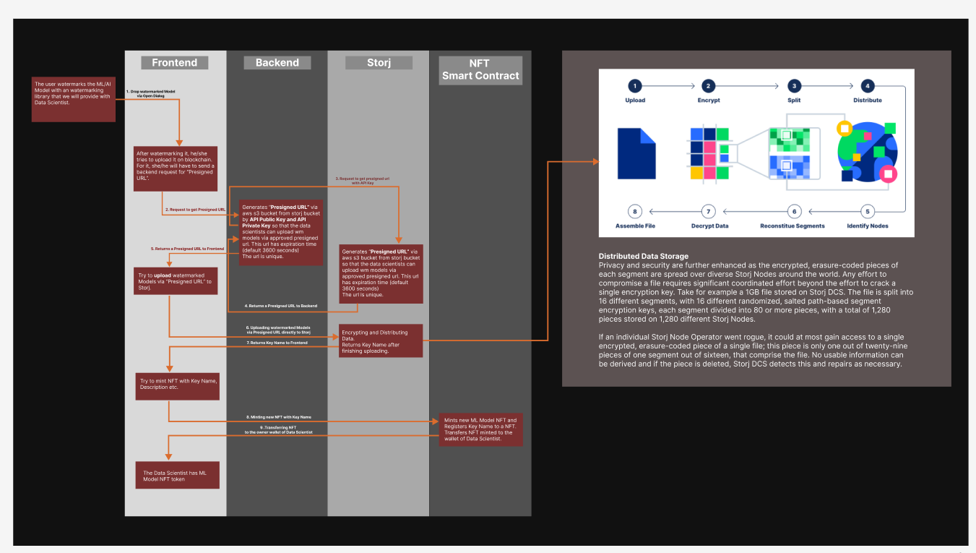.https://www.figma.com/file/dawVvfpJFsROVa8SYgjbPS/Watermarking%26Storj?node-id=0%3A1&t=A7h8kp7WlZzvLPUl-0

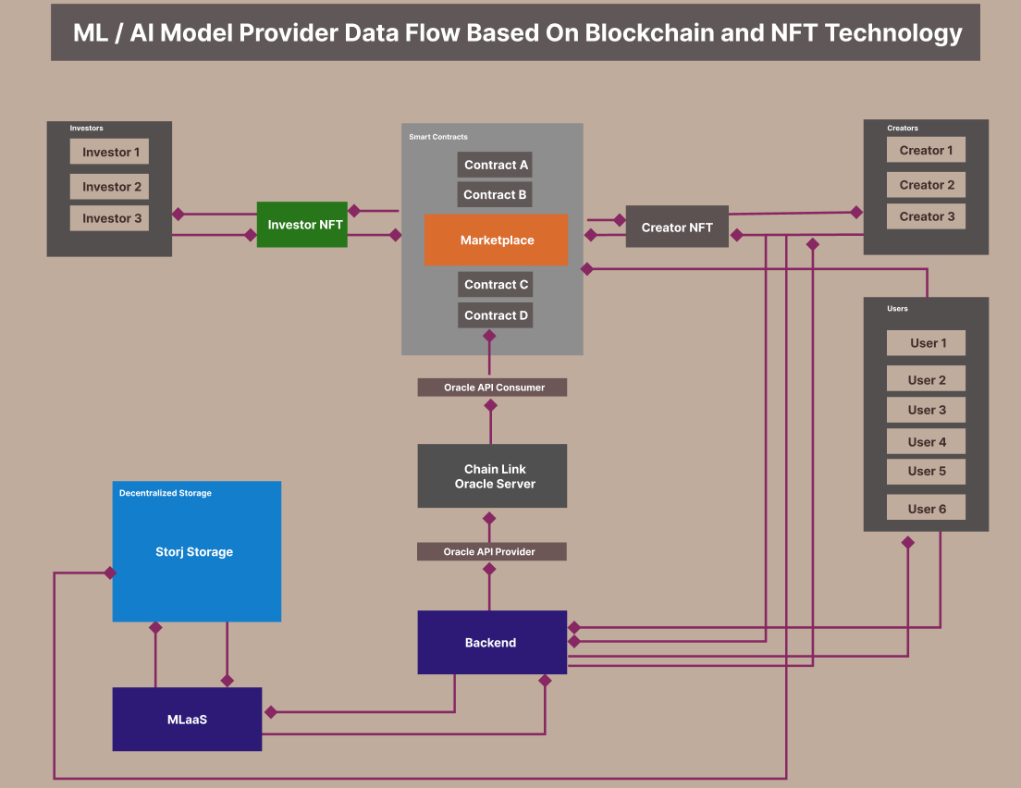

<https://www.figma.com/file/g2lGML9uyXIVPSxbtX7lWQ/Watermarked-ML-Model-NFT-Marketplace?node-id=737%3A2&t=c2YINH6QEs56s2ts-0>

**ML / AI Model Provider Data Flow Based On Blockchain and NFT Technology**

In the NFT blockchain space, many people do not want to invest in traditional NFT projects.

Therefore, most people currently want to invest in NFTs that are really valuable and meaningful.

NFT technology, one of the blockchain technologies, is used to track when, how much, who invested in which projects, and how much profit has been made so far, and to protect them in the blockchain.

And investors can resell NFTs on the market at a higher price depending on demand.

But your project is more complex than the traditional NFT.

Why more complex?

Because it is difficult for us to implement the project with only one type of NFT.

So, in this project, two types of NFT will have to be used.

1. NFT for ML/AI Model License as a creator (Creator NFT).

I think this NFT token must be a non-transferable token (Investor NFT)

2. NFT for the investors

I think this NFT token must be a transferable token so that they can resell their NFT on the Marketplace at a higher price depending on demand.

In more detail, before being issued, every Creator NFT has special properties;

1. **Creator NFT**

**TOKEN\_ID** :  A property for verifying the identity of recipients, to ensure that NFTs are being sent to the correct individuals and organizations.

More specifically, in the case of tracking ownership of ML Model creator, the architecture would include a system for verifying the identity of donors and recipients, to ensure that NFTs are being sent to the correct individuals and organizations. In the case of preventing coupon fraud, the architecture would include a system for verifying the identity of coupon users to ensure that they are the intended recipients of the coupons.

Creator NFT will have to have the following properties.

**TOTAL\_SUPPLY**: every creator NFT has a different maximum supply of tokens representing ownership in the AI model in the smart contract to limit the number of investors.

e.g. if a creator limits the number of investors to 20, we set the maximum supply of tokens (TOTAL\_SUPPLY) to 20. Once all the tokens are sold, the smart contract will no longer allow any more purchases.

**MIN\_AMOUNT**: Every NFT may be subjected to malicious attacks.

e.g. Even if TOTAL SUPPLY = 20, an attacker may block someone else's investment by making 20 repeat investments of very small amounts ($1) each time using a different wallet.

NAME: ML/AI Model name

DESCRIPTION: the description about ML/AI Model.

CREATED\_AT: data time launched.

INPUT\_PARAMS: every ML/AI Model will need input parameters.

e.g. parameter name: car speed, type: number

OUTPUT\_PARAMS: every ML/AI model will need output parameters.

e.g. Amount of Fuel: Approximate amount of fuel consumed.

TOTAL\_AMOUNT: Whole  amount invested in a NFT

**2. Investor NFT**

The investor NFT is more complex than the Creator NFT.

Every Creator NFT includes only independence properties like NAME, MAX\_AMOUNT, TOTAL\_SUPPLY.

But unlike the Creator NFT, the investor NFT includes dependence properties.

The dependence property will be a Creator NFT.

Investor NFT will have to have the following properties;

TOKEN\_ID: A property for verifying the identity of recipients, to ensure that NFTs are being sent to the correct individuals and organizations.

More specifically, in the case of tracking ownership of ML Model investment, the architecture would include a system for verifying the identity of donors and recipients, to ensure that NFTs are being sent to the correct individuals and organizations. In the case of preventing coupon fraud, the architecture would include a system for verifying the identity of coupon users to ensure that they are the intended recipients of the coupons.

MODEL\_ID: It indicates which model investor invested in.

This is from the token ID of CREATOR NFT.

INITAL\_INVESTMENT\_AMOUNT: the initial amount of investment when being issued.

LAST\_TRADING\_PRICE: last trading price

TRADING\_HISTORY: Trading history

TOTAL\_PROFIT: Whole profit from when invested in the Model NFT

**1. We can move forward with next phase and develop over the next 3 weeks.**

 Okay. I can start working on it tomorrow.

1. **However, I need help in create manually NFTs so I can promote them and sell them** immediately.  How can you help?

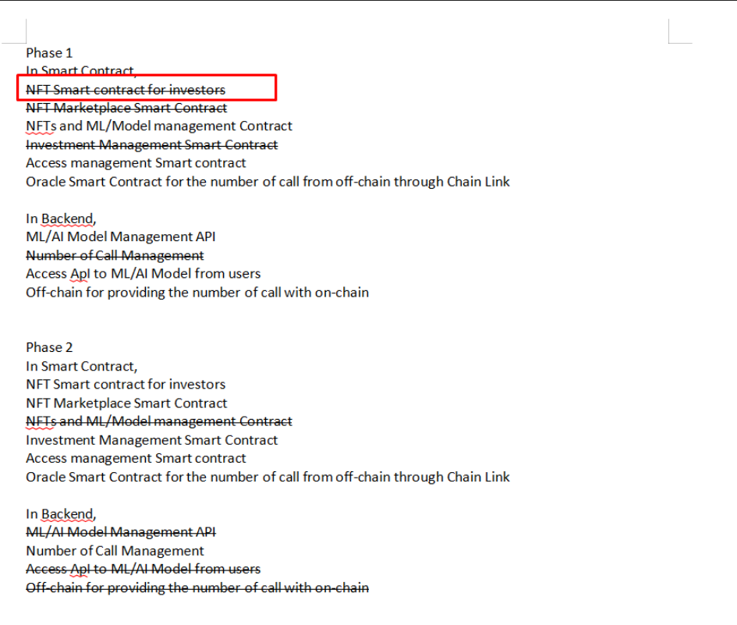

If so, we need to make Investor NFT include in 1 phase.

I can complete even a NFT smart contract if you can give me 5 - 7 days.  
  
I have a few questions.

**- Do you think they can use cryptocurrency wallets by themselves?  
- Do you think they have enough ETH, or USDT to buy NFTs using cryptocurrency?  
- Are all Investor NFTs the same price?  
- Are all Investor NFTs for only one ML/AI Model?  
In other words, do you want an Investor NFT Smart Contract for only one ML/AI Model at the current stage?**

1. **Finally, I sent you a simple problem for application I am working on for churches that is desribed in the document I sent.  Do these projects overlap?  Can I solve my church problem by completing #1?**To do that, you will have to include an Investor NFT smart contract even if it is difficult.  
   It's hard to make it include, but you can manually process as much as you want in step 1.

**1. Where is the watermark stored in the design?**

[https://www.figma.com/file/dawVvfpJFsROVa8SYgjbPS/Watermarking%26Storj?node-id=0%3A1&t=A7h8kp7WlZzvLPUl-0](https://www.figma.com/file/dawVvfpJFsROVa8SYgjbPS/Watermarking&Storj?node-id=0:1&t=A7h8kp7WlZzvLPUl-0" \t "https://mail.google.com/mail/u/1/" \l "inbox/_blank)  
Please, check this diagram. I showed you this diagram before.

**2. Where is the ecryption key stored in the design?**

I explained to you already.

Please, check our past emails.

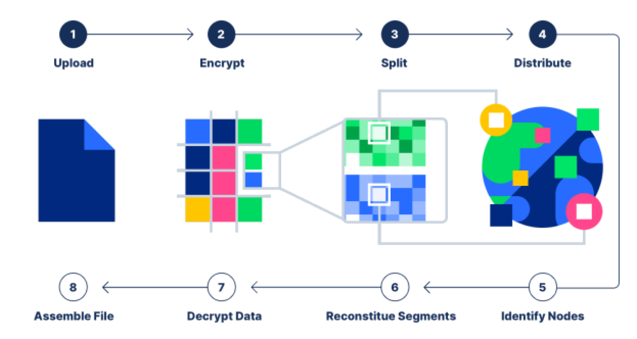

Distributed Data Storage  
Privacy and security are further enhanced as the encrypted, erasure-coded pieces of each segment are spread over diverse Storj Nodes around the world. Any effort to compromise a file requires significant coordinated effort beyond the effort to crack a single encryption key. Take for example a 1GB file stored on Storj DCS. The file is split into 16 different segments, with 16 different randomized, salted path-based segment encryption keys, each segment divided into 80 or more pieces, with a total of 1,280 pieces stored on 1,280 different Storj Nodes.  
  
***If an individual Storj Node Operator went rogue, it could at most gain access to a single encrypted, erasure-coded piece of a single file; this piece is only one out of twenty-nine pieces of one segment out of sixteen, that comprise the file. No usable information can be derived and if the piece is deleted, Storj DCS detects this and repairs as necessary.***

***I think Storj storage is a perfect fit for our project to handle big data.  
  
Advantage of Storj Storage:  
1. low price ($7/TB monthly) including additional costs, such as contract formation fees and bandwidth fees for uploading and downloading files.  
2. free 150G storage and 150G Bandwidth  
3. According to Storj Labs, Tardigrade storage is well suited to backups, archives, media content, hybrid cloud storage services, large file transfers, log files over 4 KB and database snapshots.  
4. Storj storage is S3-compatible, with data broken into smaller segments, encrypted using AES-256-GCM symmetric encryption and stored across the global network, like Sia.  
5. global P2P network  
6. high security  
7. full decentralized cloud storage.  
  
  
The next problem was to encrypt the model file.  
  
To solve this problem, data scientists will first have to upload the model files to our server, and then the server will have to encrypt it and also upload it to the blockchain storage.  
It will consume almost twice as much time as uploading directly to the blockchain storage and will consume a lot of server performance to encrypt the file.  
Therefore, we needed to select a specialized blockchain storage that is automatically encrypted by the scientist directly uploading it to the blockchain storage.  
So, I chose Storj as Blockchain Decentralized Storage.***

Note:

Please, use this wallet address from now.

0x171c8C090511bc95886c9AAc505dB3081FE72F97